Energy management system in solar powered applications

The system typically consists of Energy source (Solar panels) and standardized energy storage modules consisting of either high power(HP) or High energy (HE) devices or combined along with the Master control unit and Power distribution unit .

Solar panels are used as energy source and Li-ion battery with specific configuration is chosen as Energy Storage system(ESS).Different types of ESS such as Electrical double layer capacitors (EDLC) can be incorporated as well.

The load must be able to utilize the energy from the two or more sources efficiently.
The following cases are possible in solar powered vehicles
Case1:
When sufficient power is generated by solar panel - power flow must be completely towards the load , in case of excess power generated more than required . The excess power is utilized in charging the battery.
Case 2:
when the solar power is very very less compared to required, the load power requirement is met from the battery.
Case 3:
when power from solar cell is adequate but not sufficient enough to meet load demand, the requirement is met by utilizing the battery as well.

The system must switch between the above configurations

A topology of the Hybrid energy storage system needs to be chosen while keeping in mind the battery charging configuration. Since the load is controlled using a control unit (flight controller) , it eliminates the need for an extra power converter. Therefore, a passive energy storage topology is chosen along with a Solar charger sub-system which includes a Battery charge controller with MPPT.

The battery charge controller is a buck-boost switching regulator battery charger that implements a constant-current constant-voltage (CCCV) charging profile used for battery types such as Li-ion. The device operates from input voltages above, below or equal to the output voltage and is powered by solar panel.

A Master Control Unit ,acquires data from the current and voltage sensors and sends the control signals to the switching circuitry based on the inputs obtained and load requirements.

A power distribution unit then distributes the power to different loads.

Low-level component control includes connection of energy storage systems along with dc-dc converters and sensors linked with them.An Intelligent control algorithm will decide the optimum use of power, such as employing a PID based control strategy.

***Block diagram

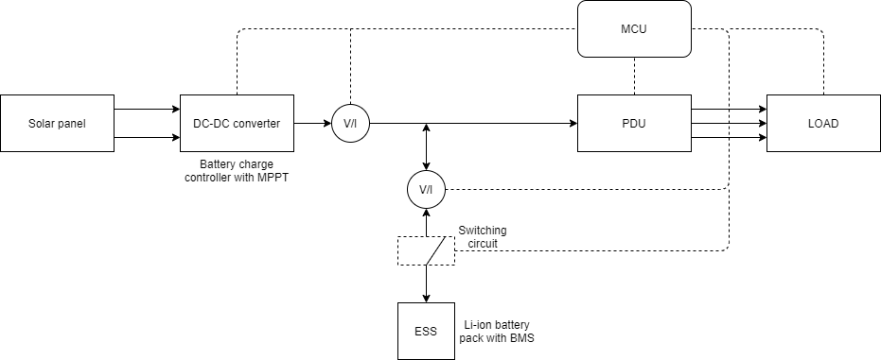

Fig. 1.1 Basic configuration of the energy management system

Further as the complexity of the system increases, wherein more number of Energy storage systems are employed ,topology changes with inclusion of power electronic converters and switching elements.
The new topology may be active, semi-active or discrete hybrid. JES Review of system topologies for hybrid electrical energy storage systems

The next control strategy is the high level supervisory control (HLSC) which consists of event-based or time-based conditions that coordinate the component level operation to improve overall vehicle performance and energy consumption. HLSC is classified into two; rule-based (RB) control, and optimization-based control.Rule-based (RB) control techniques are based mathematical, heuristic, and human expertise generally with an analytical knowledge of a predefined driving cycle. RB can be categorized into deterministic RB and fuzzy RB. In optimization control, the controller is optimized based on the cost function of the system, thus it is almost perfect. However, the controllers are sensitive to noise and parameter changes as they consider the entire dynamic and static behaviors of the system components. Optimization control is divided into global optimization and real-time optimization (RTO) methods. There are lots of strategies under each subdivision of RB and optimization-based control. Few examples are Linear programming ,genetic algorithm, adaptive fuzzy RB,Neural network, Model predictive control etc.,

A Review of Energy Management System in Battery Electric Vehicle with Hybrid Electrical Energy Source

